Summary
ELDCA Working Group Meeting
April 12, 2018
St Paul AME Church
Eastwick, PA
6:00 pm - 8:00 pm

6:00 pm Opening Remarks - Margaret Cobb, Executive Committee

                - Purpose and mission of the consolidated working group
                - Review of agenda and primary focus of this working group meeting
                - Introduction of the working group co-chairs: Chere Driver, Eileen San Pedro

Topic #1: Geotechnical comments/questions

Borrow material- (Dr. Stark) (Page 6 of TASC document provided by Skeo) - posed question about the selection of the 4 sites for the borrow material. Based on the soil limitations in the 90% Pre-Final Design, only one of the 4 sites meets the correct soil type criteria. Concern voiced if this one site will have adequate material for the project.

Plastic- explanation shared about the significance of plastic soil characteristics. More plastic soils shrinks when it dries and expands when wet. Therefore material with “low” levels of plasticity is more desirable.

Josh and Jason confirmed that all 4 sites meet the criteria. There are 12 things that are looked for in the soil. A greater concern is the cost of excavating and transporting the material from one or more of the 4 potential borrow sources. The cost per cubic yard is more costly than expected. There is consideration to obtaining a soil from another vendor that would handle the hauling of their material that would have all the soil limitations in the 90% Design met.

Compaction standard vs modified - (Dr. Starke) (Page 4 of TASC document provided by Skeo)- Dr. Stark is not comfortable with Tetra Tech’s decision to use standard Proctor compaction instead of the modified proctor compaction standard. Without greater than 90% standard compaction there is a potentially greater chancethat the waste and/or cover will slide or slough to an unknown extent on any portion of the landfill slope. [standard Proctor compaction is what was the norm before modern much heavier earth moving machinery became the norm for earth moving, now modified Proctor compaction is the norm with the use of modern much heavier earth moving machinery that are in use today]. The figure below provides more information.

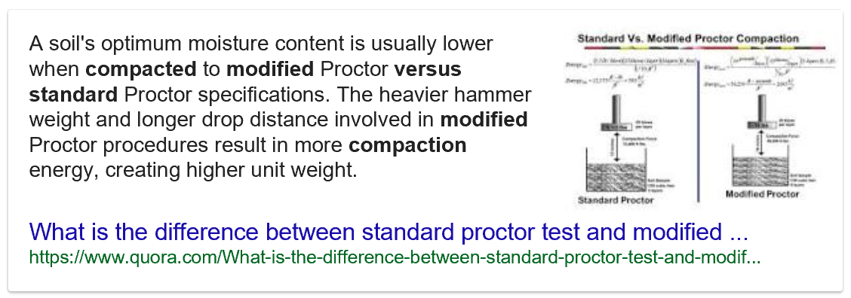

Jason (Tetra Tech – EPA Contractor) shared that 85%-90% of standard Proctor compaction is the industry standard. Goal is not to over harden the soil. Too much compaction will prevent the cover trees from growing.

JC (Tetra Tech) - 85% of standard compaction can be achieved simply by the machinery spreading the soil and driving over the soil. Dr. Stark expressed reservations about TetraTech’s choice of using the standard Proctor compaction test and not the modified Proctor compaction test. Dr. Stark asked why TetraTech chose to use that text. Jason’s response was that the factor of safety that was attained under standard Proctor testing of the borrow source materials was sufficiently high that any testing under modified Proctor would have a minimal change to the factor safety. And, that factor of safety calculation would still be much higher than the minimum factor of safety required for the cover. While slope is 3 to 1 or less in most places, Dr Stark thinks a little bit more compression is needed.

UPenn discussion- question posed about monitoring of the cap. Per Josh there is a similar cap in use in Honeybrook Pa. Monitoring lasted 5 years. No issues noted.

Topic #2: Erosion & Sediment Controls for landfill phases- (Mary)
Sequence of Construction will be done in phases by houses, park and creek. No more than a couple acres will be exposed at a time. Per requirements no more than 20. Handouts were provided to show visuals on Temporary Slope Pipe, Benches ( see attached). Recommended construction approach in the Final Design will be built from the bottom moving up-slope, allowing for enough space for leachate pipe work in the later phases of project.

Topic #3: Storm water piping & potential leachate discharge – (Derron)

We did not go over the comments one-by one due to time constraints so we focused on the more important ones. The Comments provided to the CAG and subsequently to EPA are Attached.

Technical question 1: With the understanding that the storm water pipes that discharge to Darby and Cobbs Creeks will be constructed below the leachate collection trench and thus will be in the leachate/groundwater, so that they can discharge storm water into the Creeks. Derron asked if there was another drawing, not provided in the design package provided for review that showed a clay plug or other means for blocking the flow of leachate and/or contaminated groundwater along the storm water pipes and into the Creeks. Will (Tetra Tech) replied that this was a design item that was missed and that TetraTech will be adding those design components to the final design. With Will saying that clay plugs or some other engineering control will be added to the design to prevent leachate and/or contaminated groundwater from flowing along the pipes and into the Creeks, this comment has been adequately addressed.

Technical question 2: Derron reviewed the Pre-Design Investigation Report and could not find analytical results for the SVOC (semi-volatile organic compounds) analyses that purported to have been performed on the leachate/shallow groundwater samples that form the basis of the design for the leachate collection trench. Derron asked why, given the history of PCBs contamination detected at the Landfill, the leachate/shallow groundwater samples were not analyzed for PCBs. Josh replied that EPA provided all of the data they have for the Landfill (assuming he means from groundwater and leachate samples) to Pennsylvania Department of Environmental Protection (PADEP) and that PADEP gave the treated leachate discharge standards to EPA [in other words… a National Pollutant Discharge and Elimination System (NPDES) permit is required in order to discharge the treated leachate to Darby Creek] and that EPA had no hand in deciding what those limits are. If the CAG would like more explanation regarding the discharge standards for the treated leachate being discharged into Darby Creek we will need to contact PADEP. Per the attached comments, some of the discharge limits appear to be high and we should seek further explanation from PADEP.

Topic #4: Streambank Stabilization- (Dr Stark) Questions posed - Will the 3 types of structures stabilize the banks (Mud sills, Log vanes and wood crib walls, Page 9 & 10 of TASC document provided by Skeo). Josh shared that they walked the creek today near Saturn Place where there may be more erosion. A crib wall may be considered for this area. Explained that the use of logs is preferred over rocks. The logs selected are more resistant to decay and are suitable to control and will last sufficiently longer so that natural growth of trees that may occur behind it and the logs will no longer be needed to hold the banks in place. Mud sills are good for high energy sharp turns. Less invasive to construct. Log vanes will redirect water toward center of creek faster than bank. EPA and DEP will maintain structures expecting tree structures will hold soil in place.

Topic #5: The de-watering plan- plan at present (per the attached comments) is to pump water removed from excavations the waste to the top of the Landfill and discard it on the ground surface. The concern is that when there is construction below the water table in the groundwater (storm water pipes into the creeks and creek bank stabilization structures) a great deal of water will need to be pumped. We were not comfortable with those potential volumes of water being discharged on top of the landfill, whether it is capped or not.

Josh shared that EPA is requiring the contractor to prepare a construction dewatering plan and present to EPA for approval. EPA will meet with the selected contractor to discuss their plan for managing the water generated during construction. To address our concern, Josh said that changes will be made to the specifications to include possibly some limitations on the amount of water that can be pumped on to the top of the Landfill for disposal and the addition of other measures (possibly frac-tanks) for management of the contaminated water encountered during construction. Josh understood the concern and is changing the specifications to reflect the expressed concern and his explanation adequately addresses this concern.

Topic #6: Leachate treatment

Concerns were expressed about the capacity of the equalization tank designed for the treatment wetlands. JC explained that the tank has been adequately designed. Some concern was raised regarding whether the treatment wetlands were going to be large enough to handle the actual vs. modeled leachate flow. JC and Josh said that there is adequate space available to expand the leachate treatment wetlands if more there is more leachate to treat than the model has predicted. JC and Josh’s explanations adequately addressed the concerns regarding the size of the treatment wetlands.

Topic # 7- Health, safety and communication: Due to limited time, a conference call will be coordinated by Margie for discussion of this topic.

Chere briefly clarified the concern.

                - How can residents contact EPA if health/safety issues come up during remediation of their yards
                - Will EPA provide materials to residents about potential health effects to determine if they have been exposed to contaminants during remediation

8:20 pm Final remarks and ADJOURN

